*Tim S. Peters & Sander W. van der Laan*

*UMC Utrecht | s.w.vanderlaan-2@umcutrecht.nl*

*CD66b pipeline versions*

Creating CD66b pipeline

Table of Contents

Iterations 2

Final version 3

Outliers 4

Outlier AE492 5

Outlier AE709 7

Outlier AE1182 9

Outlier AE1205 11

Outlier AE1357 13

CD66b pipeline versions

The CellProfiler pipeline for CD66b has been improved iteratively. For the CD66b staining we have 160 whole scale images (WSIs) where the CD66b-positive cells have been counted manually. The performance of each pipeline is determined by comparing the counts from CellProfiler to the manual counts.

# Iterations

Below you can see an overview of each iteration of the CellProfiler pipeline compared to the manual counts. In each figure the blue dots are the manual counted cells and the red dots the CellProfiler counts. For each iteration, the correlation between the CellProfiler and manual counts is given.

**CellProfiler CD66b Pipeline Version 1.1: Correlation: 0.56**

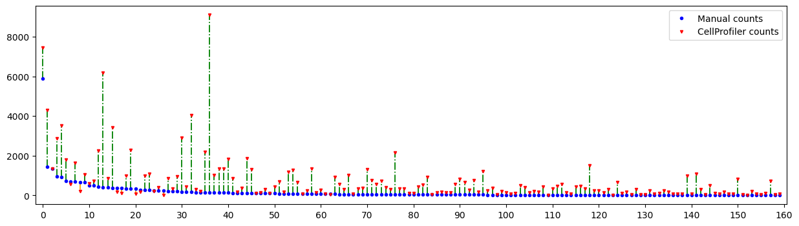

**CellProfiler CD66b Pipeline Version 1.2: Correlation: 0.70**

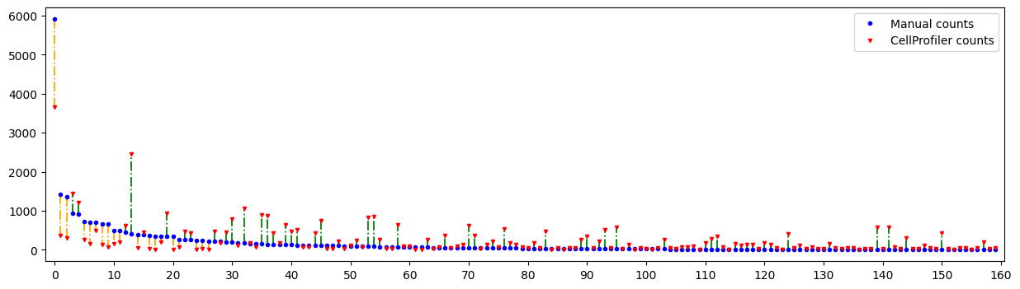

**CellProfiler CD66b Pipeline Version 1.3: Correlation: 0.82**

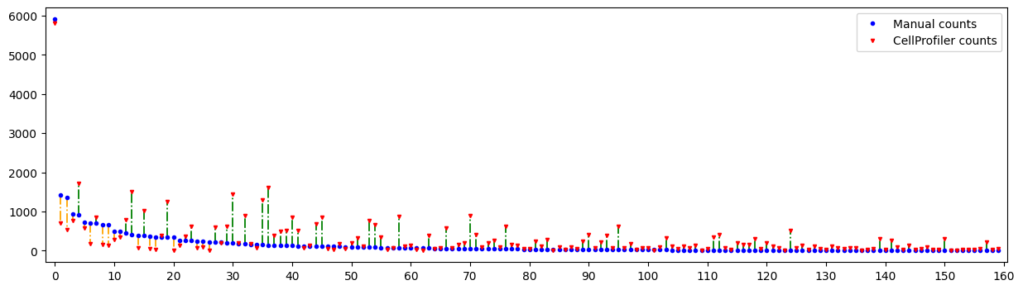

# Final version

Below is the final version that will be used.

**CellProfiler CD66b Pipeline Version 2.0: Correlation: 0.81**

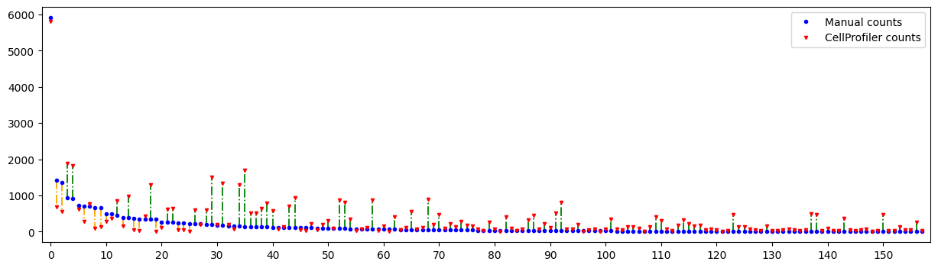

**Same plot zoomed in (without the first sample):**

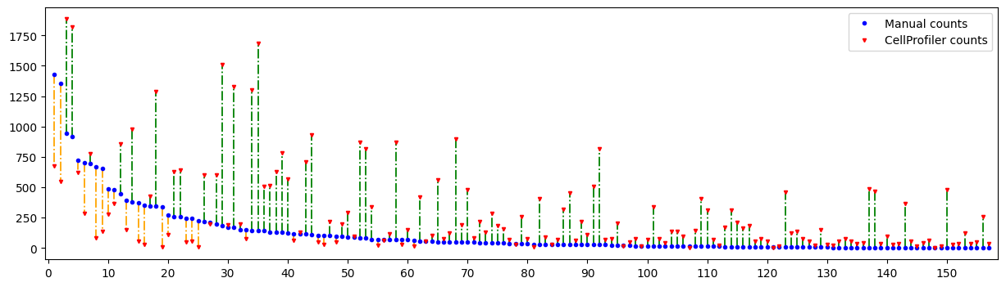

Next, we look at the same pipeline but remove outliers by looking at the median absolute deviation with a cut-off point of 3. This means that all instances with more than 3 median absolute deviations from the median are rejected. We are left with 136 out of 158 instances.

**CellProfiler CD66b Pipeline Version 2.0 (no outliers): Correlation: 0.94**

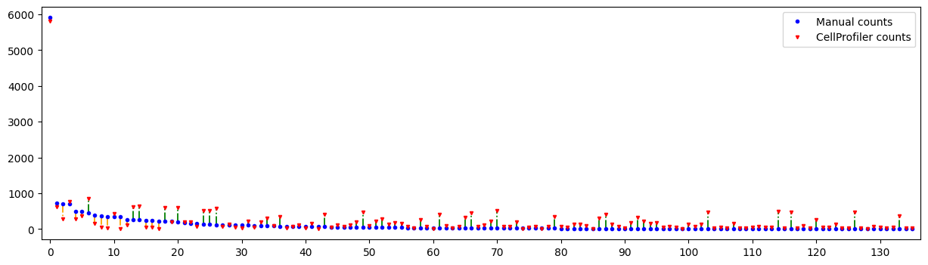

# Outliers

As you can see the final CellProfiler pipeline contains some notable outliers. We will discuss the top 5 of these outliers below. First, we give an overview of the CellProfiler counts vs. manual counts. After that, each of these outliers will be discussed in more detail.

***Cellprofiler CD66b outliers:***

|  |  |  |
| --- | --- | --- |
| AE Study number | CellProfiler counts | Manual counts |
| AE492 | 1685 | 141 |
| AE709 | 899 | 49 |
| AE1182 | 547 | 1353 |
| AE1205 | 817 | 26 |
| AE1357 | 1509 | 187 |

## Outlier AE492

|  |  |
| --- | --- |
| CellProfiler count | Manual count |
| 1685 | 141 |

As you can see in the top 3 example shown below, the total of only these samples adds up to 131 neutrophils, which is almost the same as the total of manual count. Because there are more tiles with neutrophil cells, the manual count is incorrect. Therefore, we assume that the CellProfiler count is more accurate too the true number of neutrophils in this slide.

**Top 10 tile with neutrophils**

|  |
| --- |
| 54 |
| 47 |
| 30 |
| 30 |
| 26 |
| 26 |
| 25 |
| 22 |
| 21 |
| 21 |

**Top 3 tiles with most neutrophil counts:**

*54 counts:*

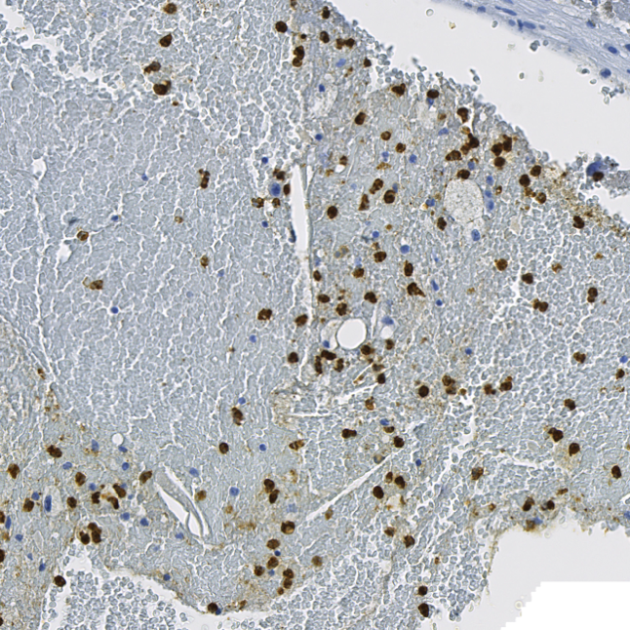 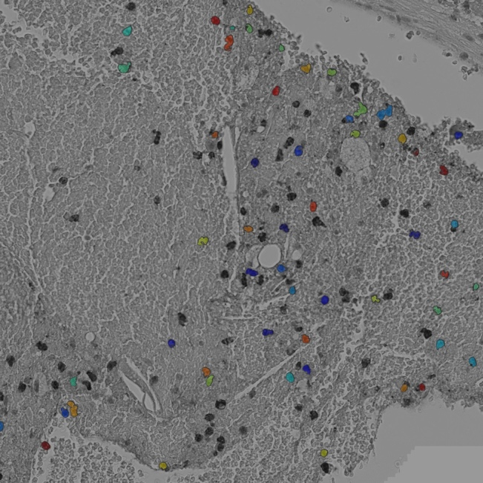

*47 counts:*

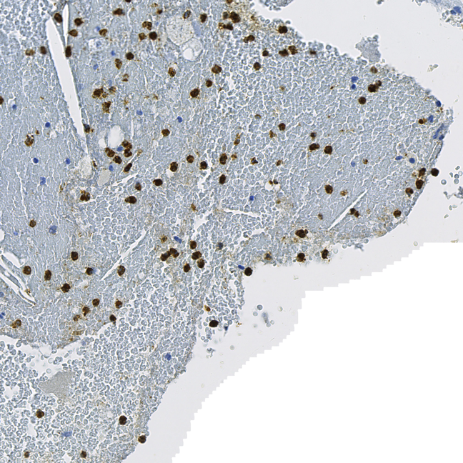 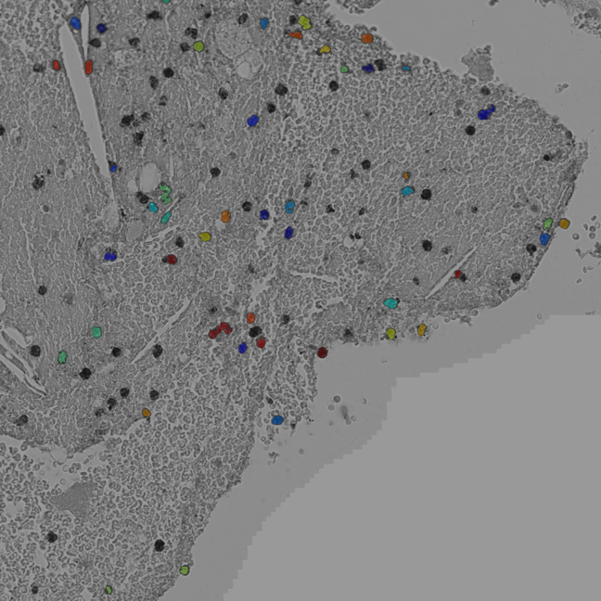

*30 counts:*

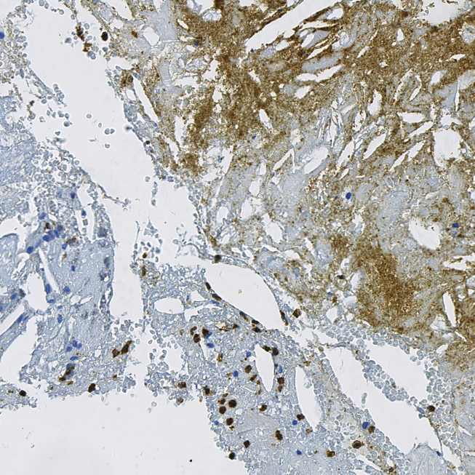 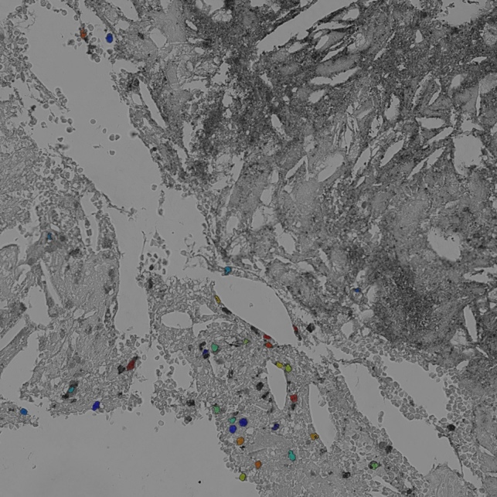

## Outlier AE709

|  |  |
| --- | --- |
| CellProfiler count | Manual count |
| 899 | 49 |

As you can see in the first example shown below, the total number of neutrophils within the first sample is more than the total manual count, which means that the manual count is incorrect. Because there are more tiles with neutrophil cells, we assume that the CellProfiler counts are more accurate too the true number of neutrophils in this slide.

**Top 10 tile with neutrophils**

|  |
| --- |
| 133 |
| 90 |
| 46 |
| 31 |
| 29 |
| 23 |
| 21 |
| 20 |
| 20 |
| 16 |

**Top 3 tiles with most neutrophil counts:**

*133 counts:*

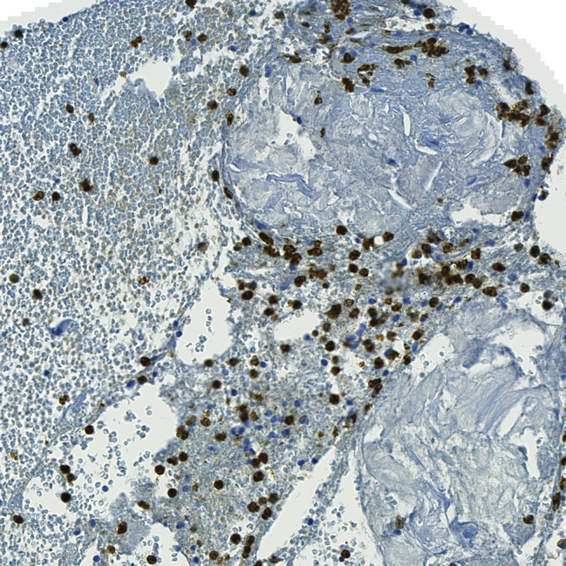 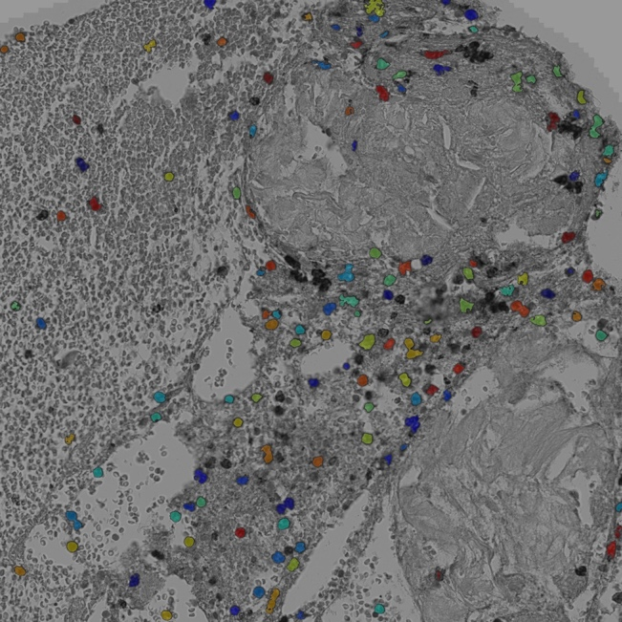

*90 counts:*

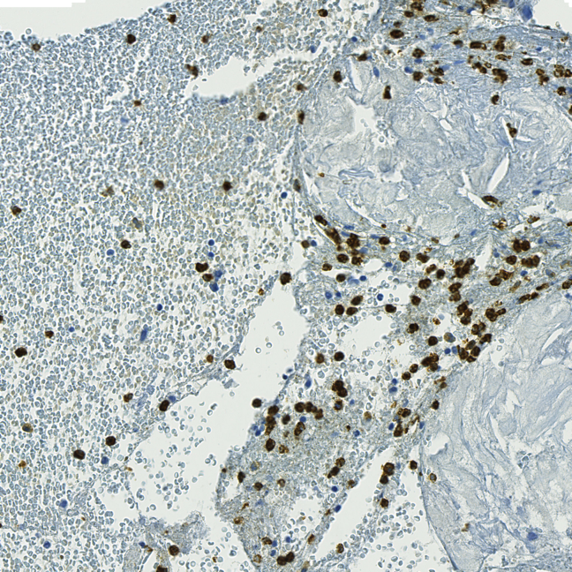 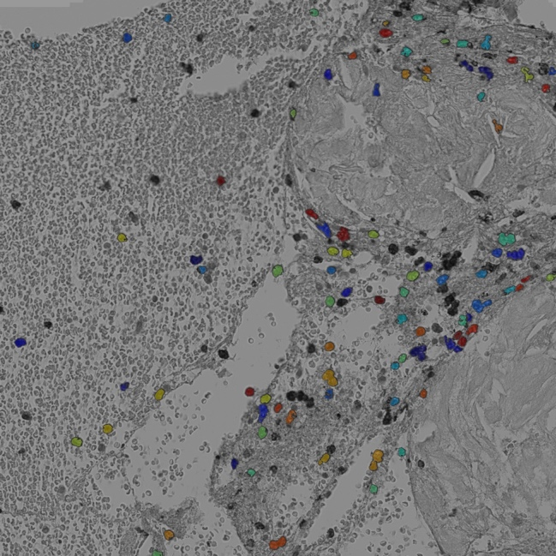

*46 counts:*

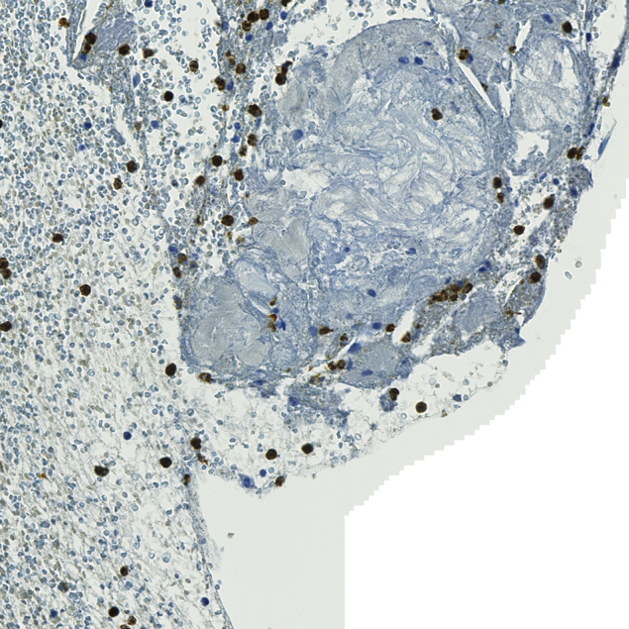 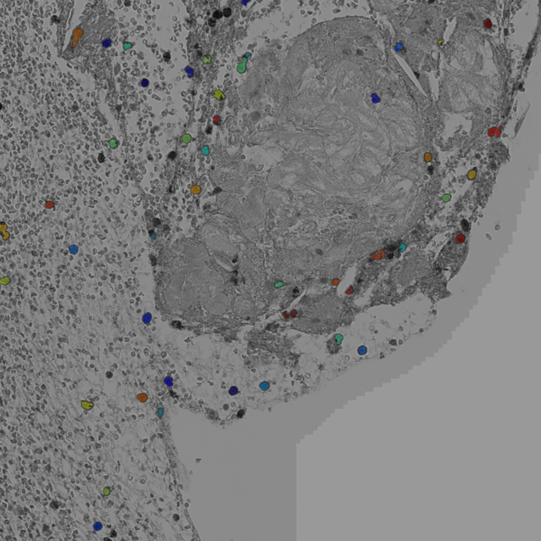

## Outlier *AE1182*

|  |  |
| --- | --- |
| CellProfiler count | Manual count |
| 547 | 1353 |

This slide is difficult to verify, but as you can see CellProfiler finds the most neutrophil counts in a slide with a lot of brown staining (which is not necessarily a neutrophil cell). CellProfiler might even count too many cells here. Therefore, the manual count cannot be accurate, because it is even higher than that of CellProfiler.

**Top 10 tile with neutrophils**

|  |
| --- |
| 66 |
| 58 |
| 29 |
| 27 |
| 21 |
| 20 |
| 20 |
| 18 |
| 17 |
| 16 |

**Top 3 tiles with most neutrophil counts:**

*66 counts:*

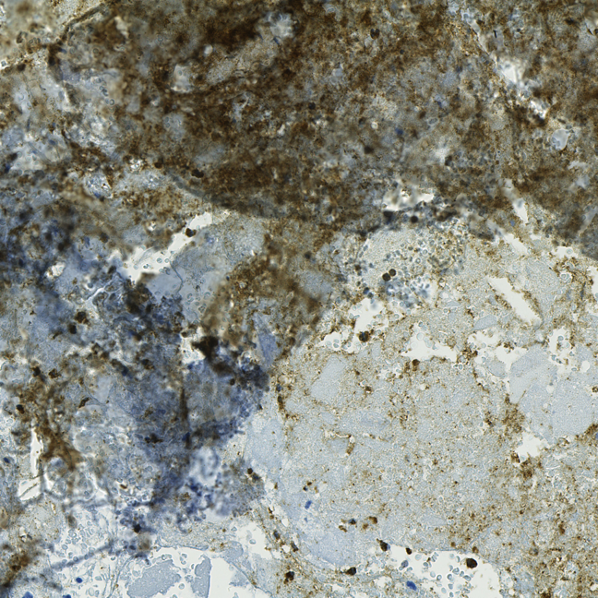 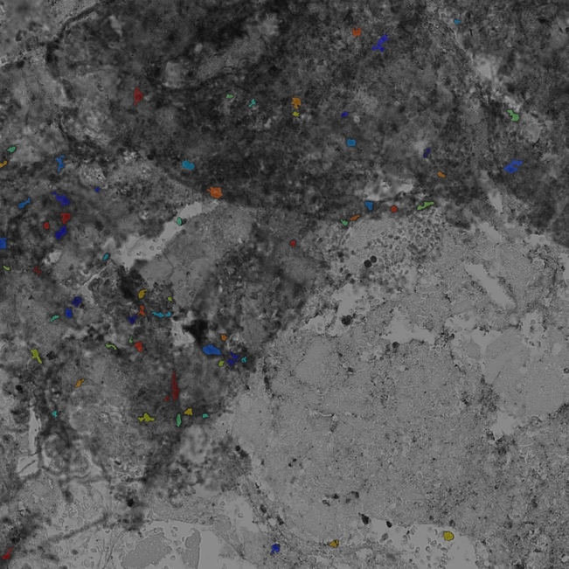

*58 counts:*

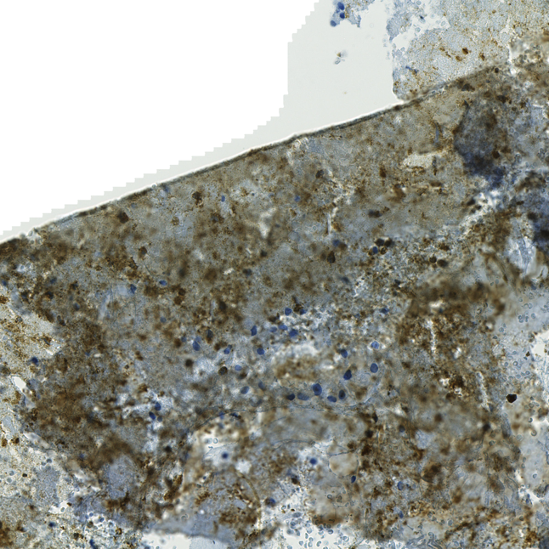 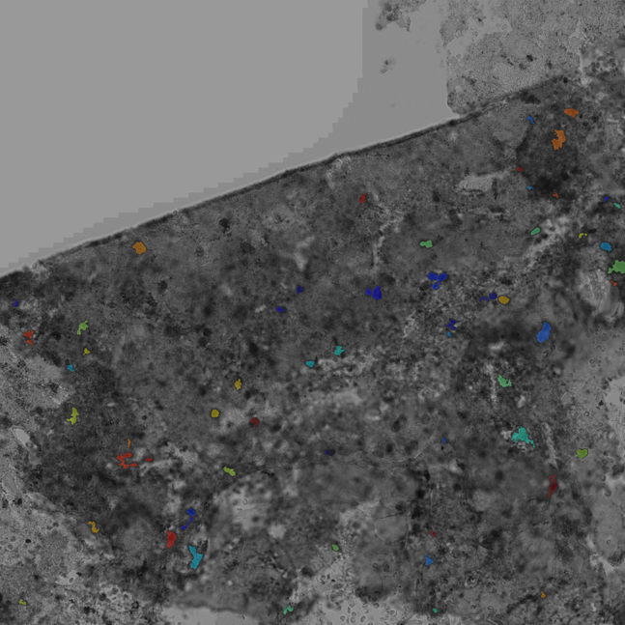

29 counts:

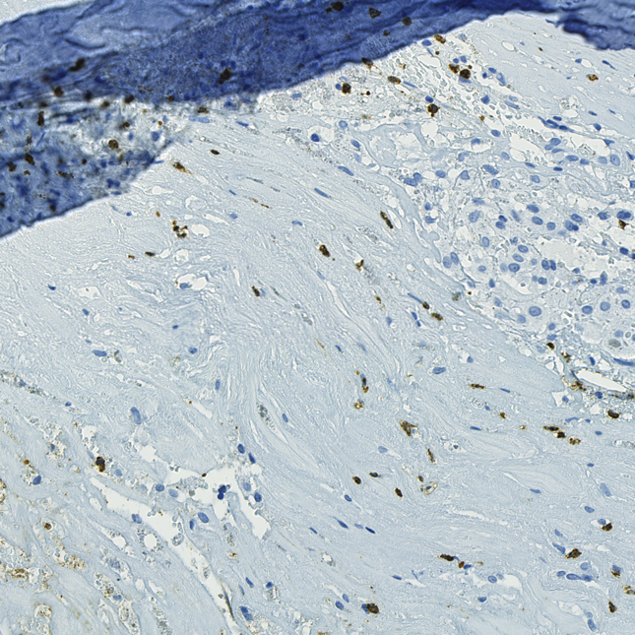 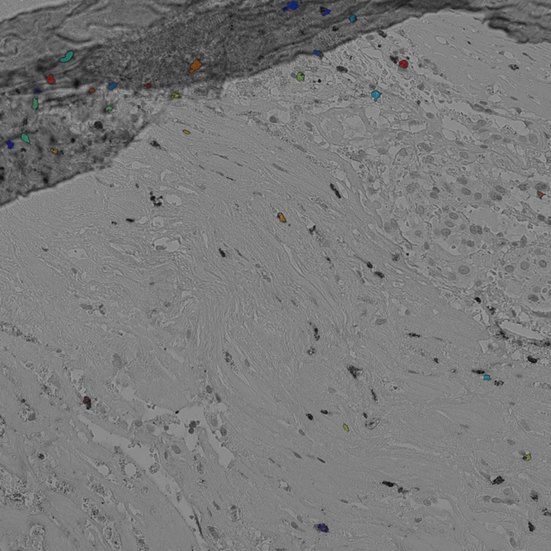

## Outlier AE1205

|  |  |
| --- | --- |
| CellProfiler count | Manual count |
| 817 | 26 |

As you can see in the first example shown below, the total number of neutrophils within the first sample is more than the total manual count, which means that the manual count is incorrect. Because there are more tiles with neutrophil cells, we assume that the CellProfiler counts are more accurate too the true number of neutrophils in this slide.

**Top 10 tile with neutrophils**

|  |
| --- |
| 58 |
| 56 |
| 50 |
| 30 |
| 26 |
| 24 |
| 23 |
| 22 |
| 18 |
| 17 |

**Top 3 tiles with most neutrophil counts:**

*58 counts:*

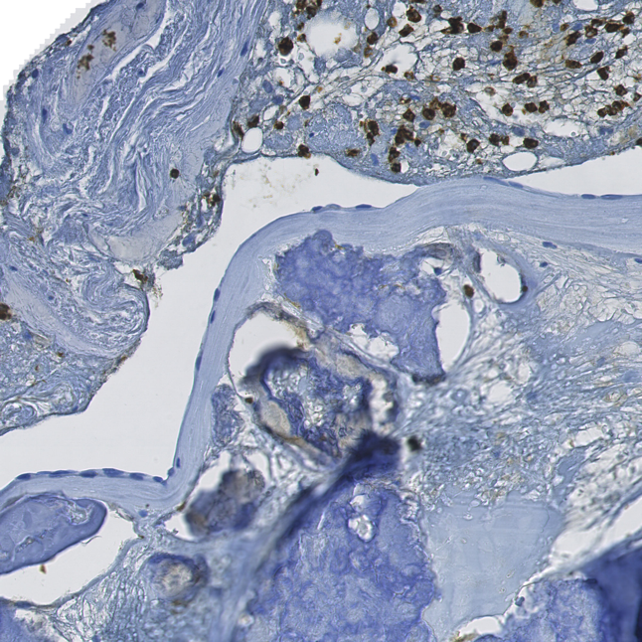 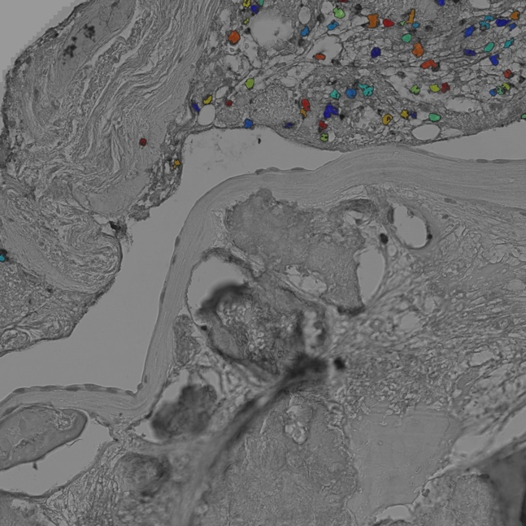

*56 counts:*

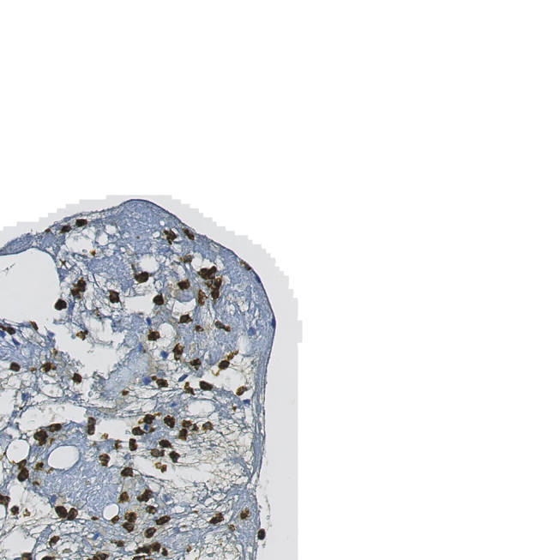 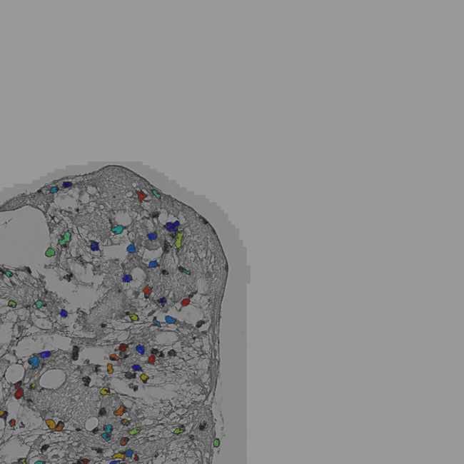

*50 counts:*

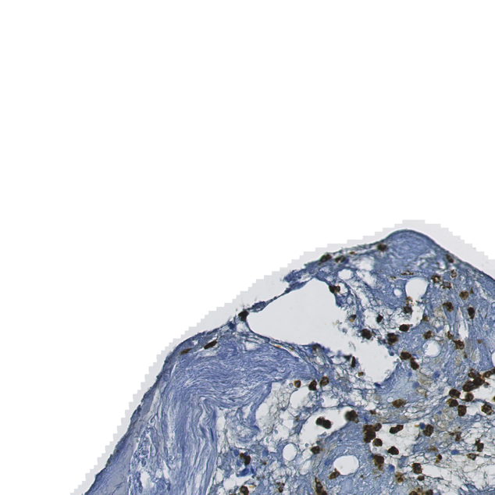 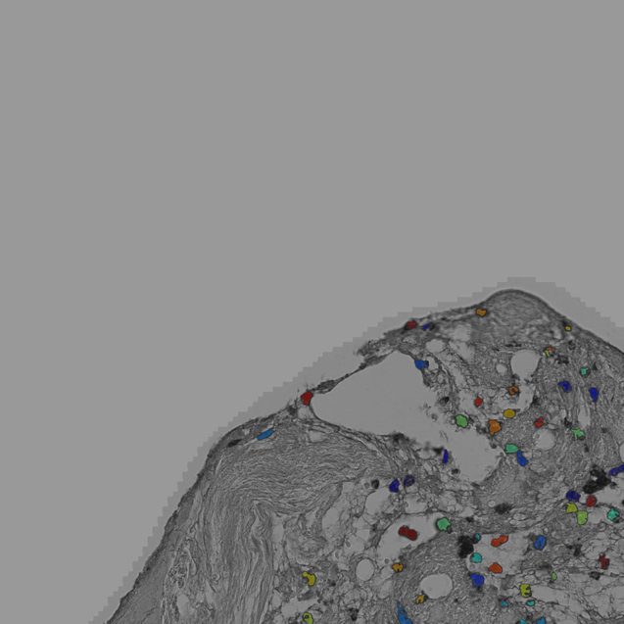

## Outlier AE1357

|  |  |
| --- | --- |
| CellProfiler count | Manual count |
| 1509 | 187 |

This slide has a lot of tiles with neutrophil counts around 30. As you can see from the first 3 examples these counts are quite accurate. The total sum of this would therefore be more than 187. Because of this, we assume that the CellProfiler counts are more accurate too the true number of neutrophils in this slide.

**Top 10 tile with neutrophils**

|  |
| --- |
| 39 |
| 34 |
| 34 |
| 32 |
| 31 |
| 29 |
| 28 |
| 28 |
| 27 |
| 27 |

**Top 3 tiles with most neutrophil counts:**

*39 counts:*

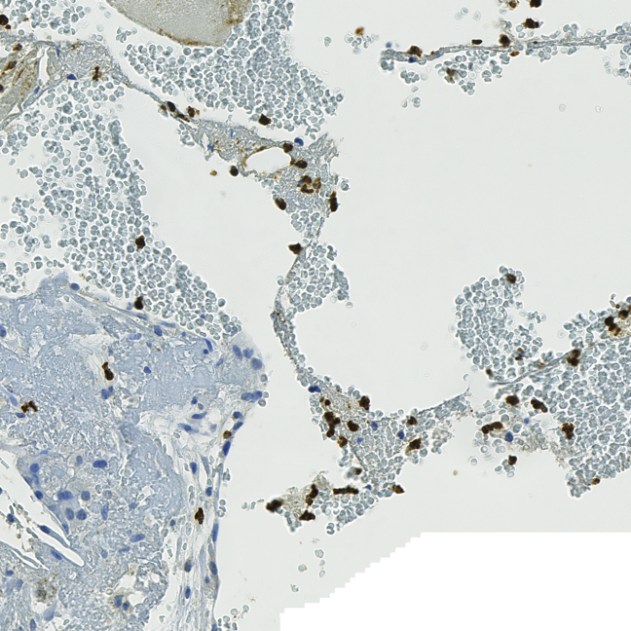 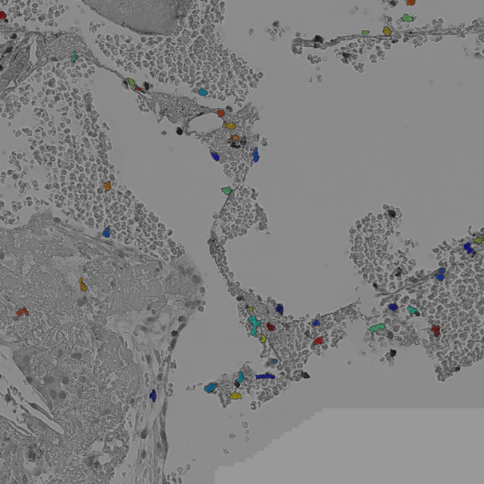

*34 counts:*

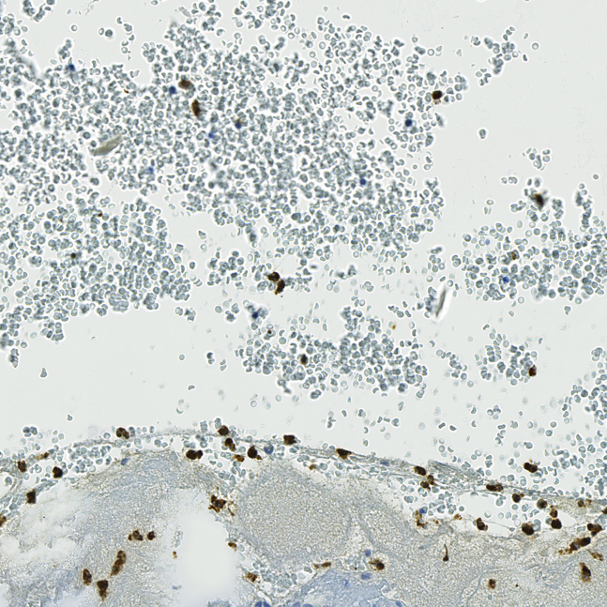 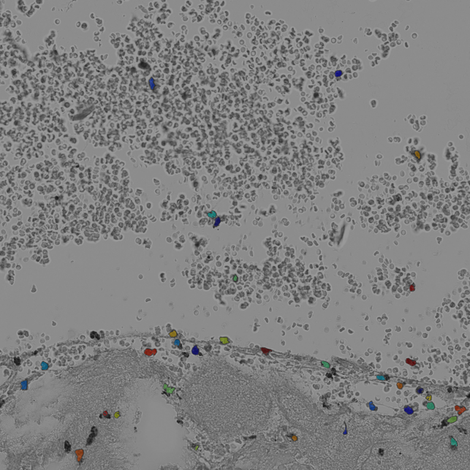

*34 counts:*

